Week-2

Session 6:
DELIMITER //

CREATE TRIGGER trg_commission_audit
BEFORE UPDATE ON Salespeople
FOR EACH ROW
BEGIN
-- 1. Validation Logic
IF NEW.commission_rate < 0 THEN
SIGNAL SQLSTATE '45000' SET MESSAGE_TEXT = 'Commission cannot be negative';
END IF;

-- 2. Audit Logging Logic
INSERT INTO employee_audit(salesperson_id, old_comm, new_comm)
VALUES (OLD.salesperson_id, OLD.commission_rate, NEW.commission_rate);
END //

DELIMITER ;

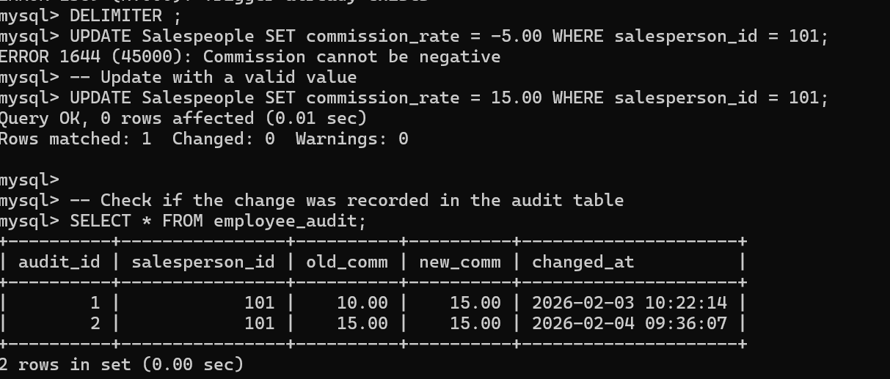

Session 7:
-- 1. Find number of days between start_date (hire_date) and today (end_date)
SELECT
first_name,
hire_date AS start_date,
CURDATE() AS end_date,
DATEDIFF(CURDATE(), hire_date) AS days_difference
FROM Salespeople;

-- 2. Find the expiry date after 30 days (e.g., Warranty Expiry for a sale)
SELECT
sale_id,
sale_date,
DATE_ADD(sale_date, INTERVAL 30 DAY) AS expiry_date
FROM Sales;

-- 3. Get Date before seven days from today
SELECT
CURDATE() AS today,
DATE_SUB(CURDATE(), INTERVAL 7 DAY) AS seven_days_ago;

-- 4. Get the records created on weekend dates (Saturday and Sunday)
-- Note: DAYOFWEEK returns 1 for Sunday and 7 for Saturday
SELECT * FROM Sales
WHERE DAYOFWEEK(sale_date) IN (1, 7);

-- 5. Read input string, convert to 'DD-MM-YYYY', and display Month Name
-- We use STR_TO_DATE to parse the string and MONTHNAME to extract the name
SELECT
'25-12-2025' AS input_string,
STR_TO_DATE('25-12-2025', '%d-%m-%Y') AS converted_date,
MONTHNAME(STR_TO_DATE('25-12-2025', '%d-%m-%Y')) AS month_display;
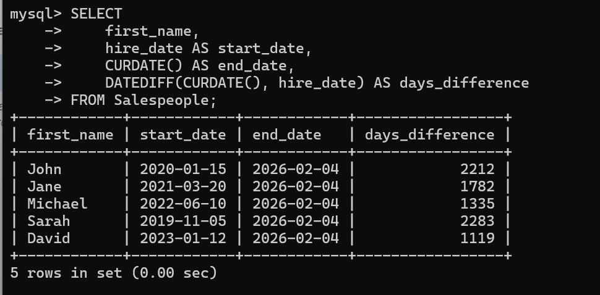
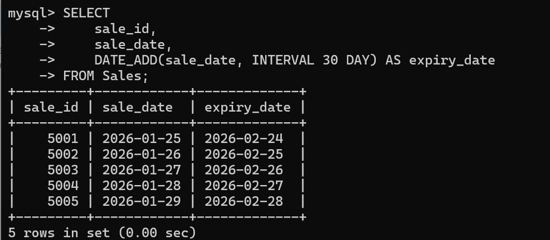
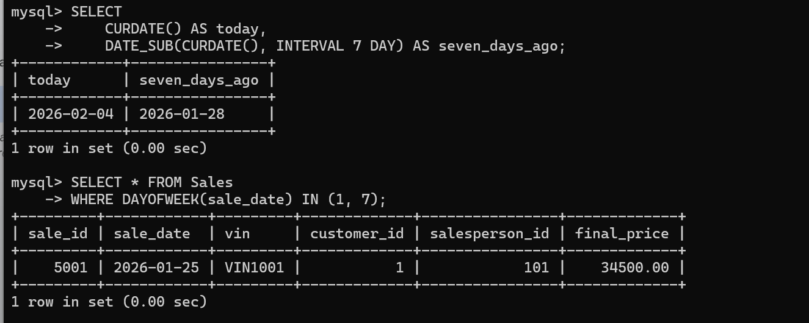
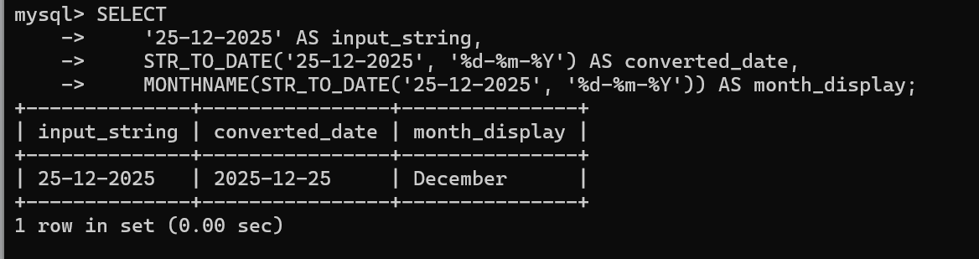

Session 8:
-- 1. Improve search performance on email column
CREATE INDEX idx_customer_email ON Customers(email);

-- 2. Create UNIQUE INDEX for username
CREATE UNIQUE INDEX idx_unique_license ON Customers(driver_license);

-- 3. Find and remove an unused index
-- First, list the indexes to find the name
SHOW INDEX FROM Customers;
-- Then, remove the index (Example: removing the email index we just created)
DROP INDEX idx_customer_email ON Customers;

-- 4. Fix slow Aadhar query using an index
CREATE INDEX idx_aadhar ON Customers(driver_license); -- Applying logic to your unique ID

-- 5. Create a composite index (status, sale_date)
CREATE INDEX idx_status_date ON Sales(vin, sale_date);

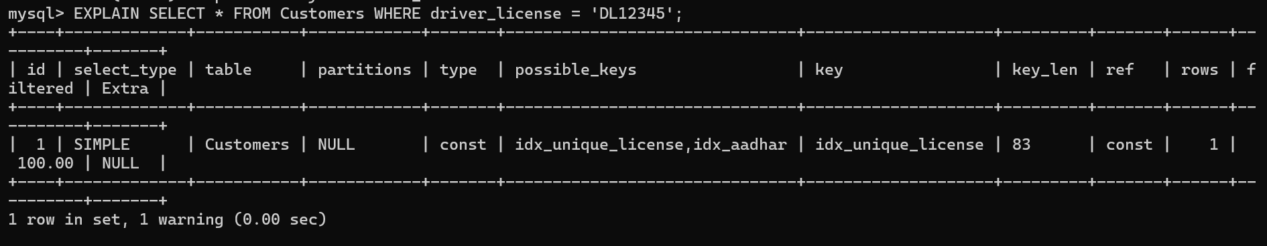
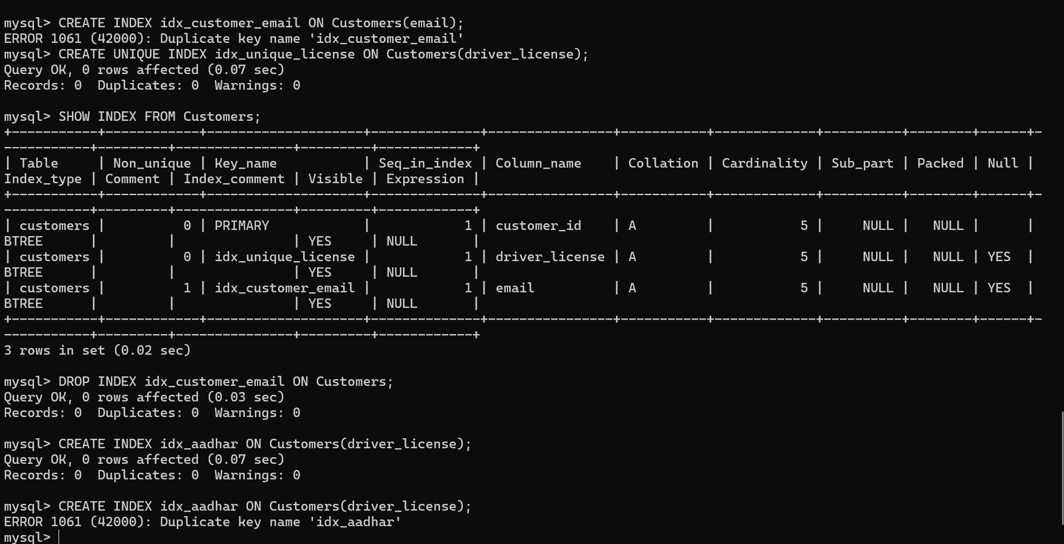

Session 9:
-- 1. Create a default password (Username before @ + '123')
SELECT
email,
CONCAT(SUBSTRING_INDEX(email, '@', 1), '123') AS default_password
FROM Customers;
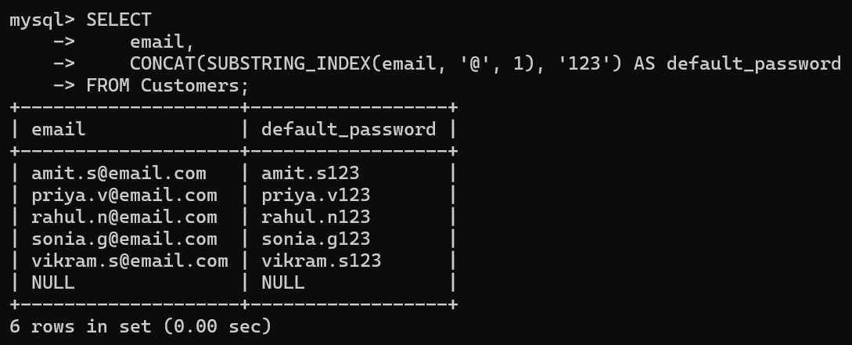
-- 2. Clean contact numbers (Remove spaces, dashes, and symbols)
SELECT
phone AS original_phone,
REGEXP_REPLACE(phone, '[^0-9]', '') AS cleaned_phone
FROM Customers;
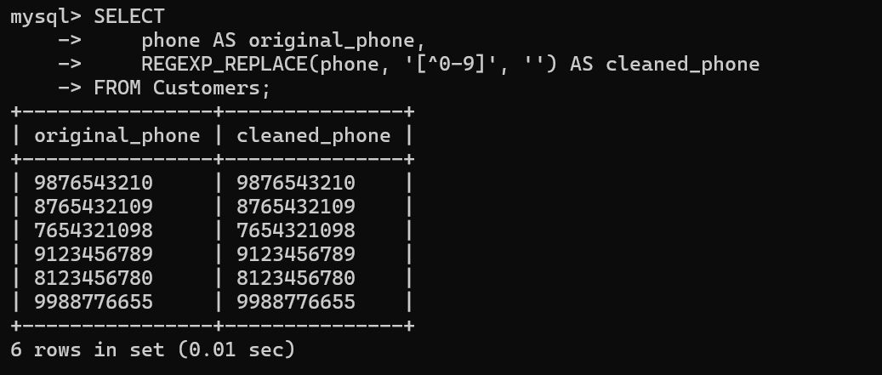

-- 3. Normalize Employee names (Mixed case to proper Upper Case)
SELECT
CONCAT(UPPER(first_name), ' ', UPPER(last_name)) AS normalized_name
FROM Salespeople;
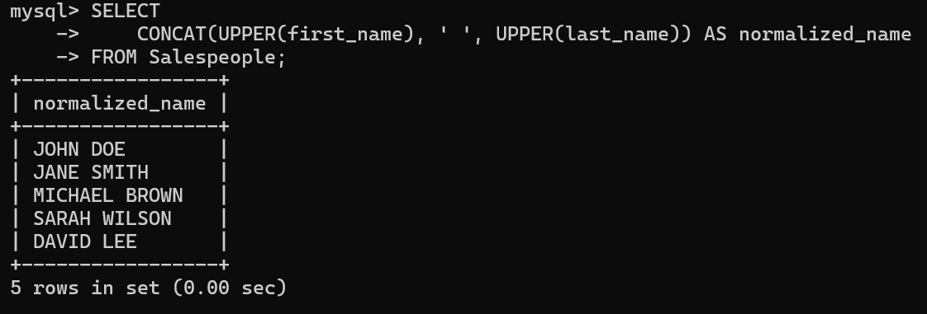

-- 4. Handle multiple fallback columns (Priority: Mobile -> Phone -> Email)
SELECT
first_name,
COALESCE(phone, email, 'No Contact Available') AS primary_contact
FROM Customers;
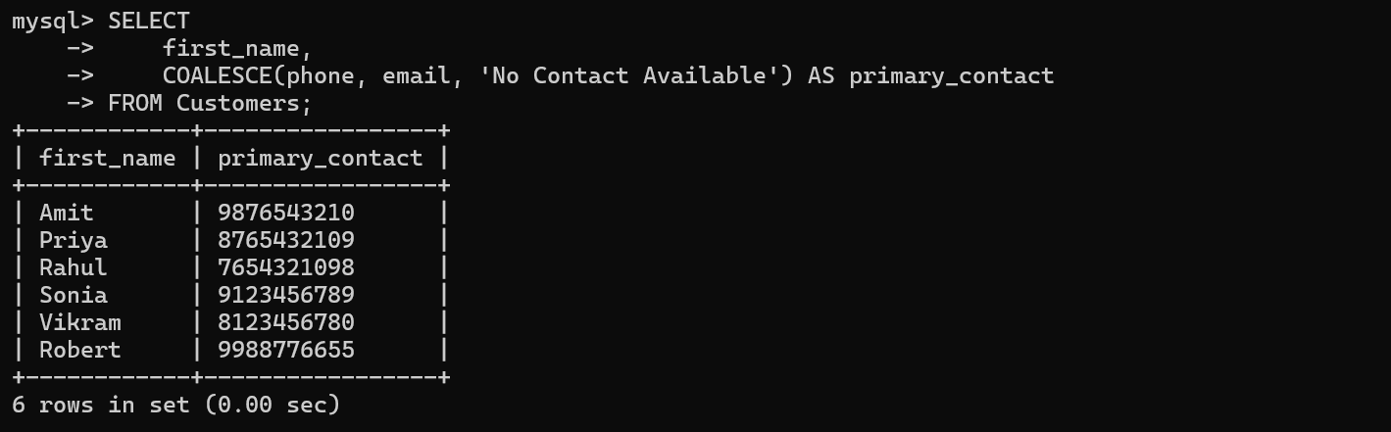

-- 5. Find average experience per department
-- Note: Since your schema is small, we group by 'showroom_location' as the department
SELECT
v.showroom_location AS department,
AVG(TIMESTAMPDIFF(YEAR, s.hire_date, CURDATE())) AS avg_years_experience
FROM Salespeople s
JOIN Sales sa ON s.salesperson_id = sa.salesperson_id
JOIN Vehicles v ON sa.vin = v.vin
GROUP BY v.showroom_location;
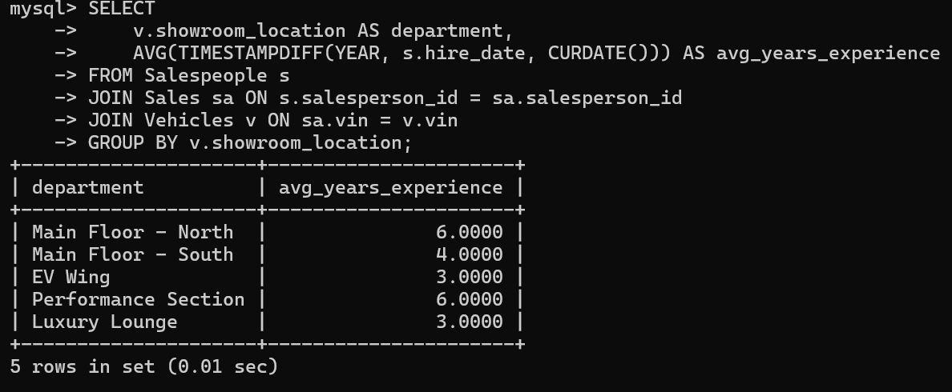

Session 10:
1.DELIMITER //

CREATE FUNCTION Get_Net_Salary(gross_salary DECIMAL(10,2))
RETURNS DECIMAL(10,2)
DETERMINISTIC
BEGIN
DECLARE net_salary DECIMAL(10,2);
-- Subtracting 10%
SET net_salary = gross_salary * 0.90;
RETURN net_salary;
END //

DELIMITER ;
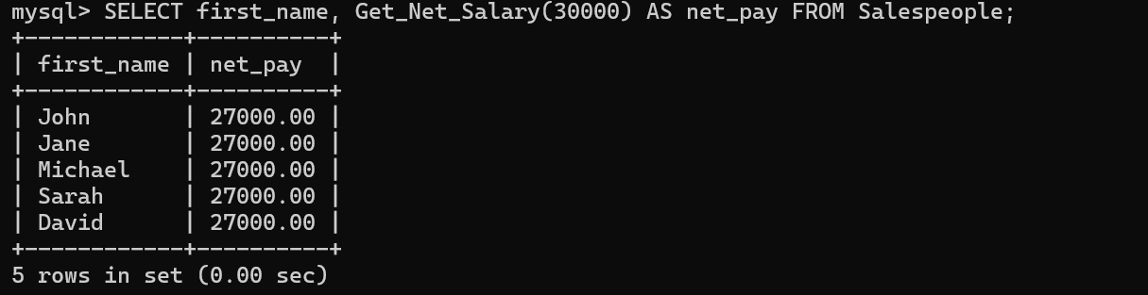
2.ALTER TABLE Customers ADD COLUMN last_login DATE;
UPDATE Customers SET last_login = '2025-12-30' WHERE customer_id = 1;
DELIMITER //
CREATE FUNCTION Check_User_Activity(last_login_date DATE)
RETURNS VARCHAR(10)
DETERMINISTIC
BEGIN
DECLARE activity_status VARCHAR(10);
IF DATEDIFF(CURDATE(), last_login_date) <= 30 THEN
SET activity_status = 'Active';
ELSE
SET activity_status = 'Inactive';
END IF;
RETURN activity_status;
END //

DELIMITER ;
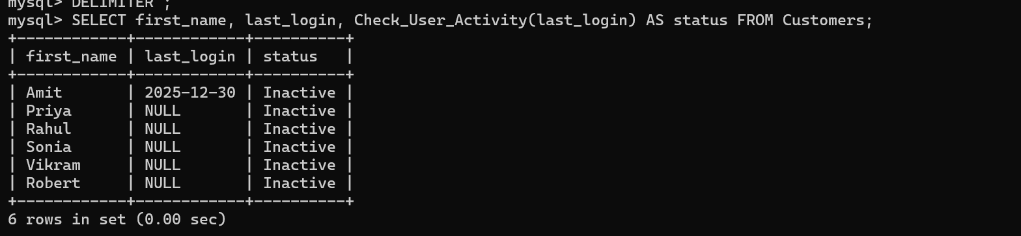
3.DELIMITER //
CREATE FUNCTION Calculate_Dynamic_Tax_Slab(income DECIMAL(10,2))
RETURNS DECIMAL(10,2)
DETERMINISTIC
BEGIN
DECLARE tax_amount DECIMAL(10,2);

SET tax_amount = CASE
WHEN income <= 300000 THEN 0
WHEN income BETWEEN 300001 AND 600000 THEN income * 0.10
WHEN income BETWEEN 600001 AND 1000000 THEN income * 0.20
ELSE income * 0.30
END;

RETURN tax_amount;
END //

DELIMITER ;
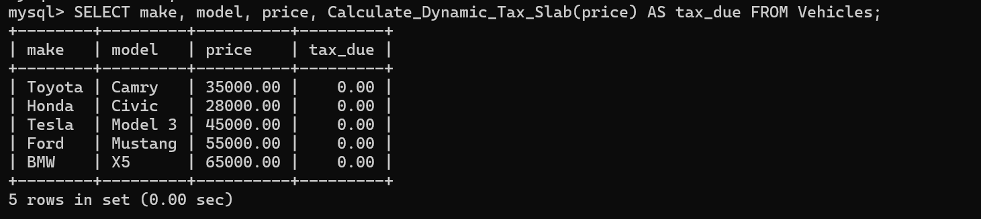

4.CREATE FUNCTION Get_Experience_Category(h_date DATE)
RETURNS VARCHAR(20)
DETERMINISTIC
BEGIN
DECLARE yrs INT;
DECLARE category VARCHAR(20);

-- Calculate difference in years
SET yrs = TIMESTAMPDIFF(YEAR, h_date, CURDATE());

-- Categorization logic
SET category = CASE
WHEN yrs < 2 THEN 'Fresher'
WHEN yrs BETWEEN 2 AND 5 THEN 'Junior'
WHEN yrs BETWEEN 6 AND 10 THEN 'Mid'
ELSE 'Senior'
END;

RETURN category;
END //
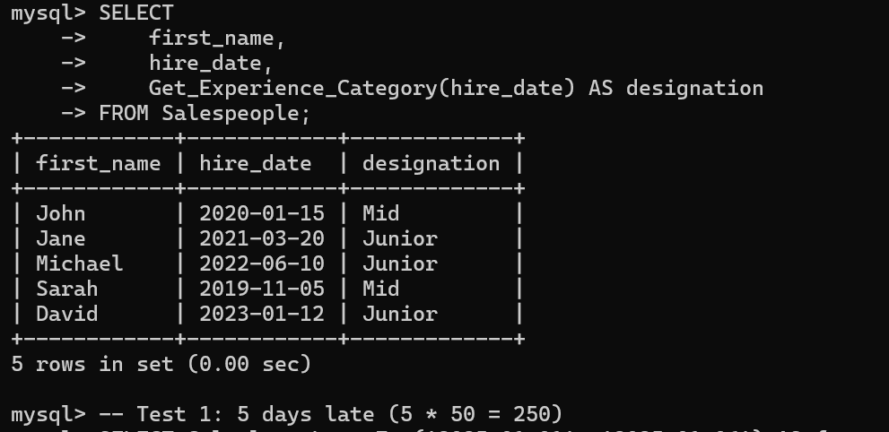

5. CREATE FUNCTION Calculate_Late_Fee(due_date DATE, return_date DATE)
RETURNS DECIMAL(10,2)
DETERMINISTIC
BEGIN
DECLARE days_late INT;
DECLARE fee DECIMAL(10,2);
-- Calculate the number of days late
SET days_late = DATEDIFF(return_date, due_date);
-- Logic: ₹50/day, if days_late is positive, else 0
IF days_late > 0 THEN
SET fee = days_late * 50;
ELSE
SET fee = 0;
END IF;
-- Limit the maximum amount to ₹1000
IF fee > 1000 THEN
SET fee = 1000;
END IF;

RETURN fee;
END //

DELIMITER ;
